Kubernetes Task -02
- Create a Simple Pod Using YAML Task: Write a YAML file to create a Pod named firstpod with an nginx container. Verify the Pod creation using kubectl get pods and check the logs of the container using kubectl logs firstpod.

Step 1. Create the YAML file
On Kubernetes master/control-plane node, create a file:
vi firstpod.yaml
Add this YAML:
apiVersion: v1
kind: Pod
metadata:
name: firstpod
spec:
containers:
- name: nginx
image: nginx:latest
Save and exit:
Esc
:wq
Enter
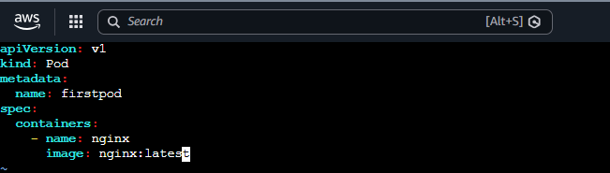

Step 2. Create the Pod
Run:
kubectl apply -f firstpod.yaml
You should see:
pod/firstpod created
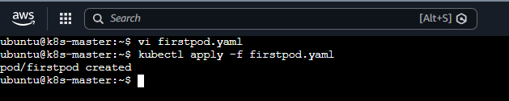

Step 3. Verify the Pod
Run:
kubectl get pods
Initially you may see:
NAME READY STATUS RESTARTS AGE
firstpod 0/1 ContainerCreating 0 5s

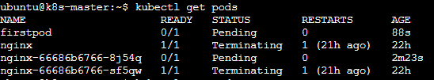
Wait a few seconds and run again:
kubectl get pods
You should eventually see:
NAME READY STATUS RESTARTS AGE
firstpod 1/1 Running 0 20s
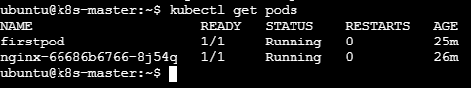

For more details
kubectl get pods -o wide

Step 4. Check the Nginx container logs
Run:
kubectl logs firstpod
You should see Nginx-related startup/access log output. If there have been no requests yet, the output may be very small or even empty depending on the Nginx image/version.
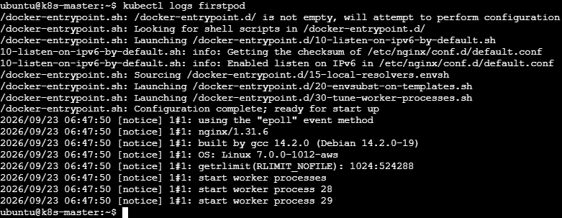

2. Set Environment Variables in a Pod Task: Modify the YAML file to include environment variables myname: sabair and City: Hyderabad. Deploy the Pod and use kubectl exec <pod_name> -- env to check if the environment variables are set properly.

Step 1: Edit the YAML file
vi firstpod.yaml

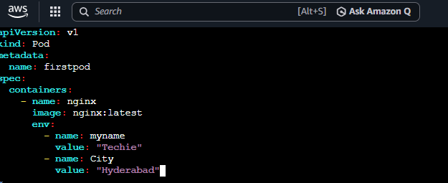

Save and Exit

Step 2: Deploy the Pod
Because the existing firstpod cannot simply be modified for this change, delete it first:
kubectl delete pod firstpod
Then create it again:
kubectl apply -f firstpod.yaml
You should get:
pod/firstpod created
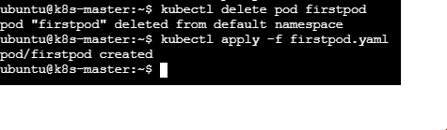

Step 3. Check the Pod
kubectl get pods
Wait until you see:
NAME READY STATUS RESTARTS AGE
firstpod 1/1 Running 0 ...

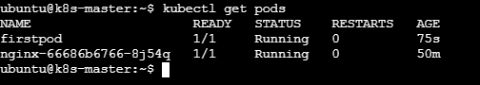

Step 4. Check the environment variables
Run exactly what the task asks:kubectl exec firstpod -- env
You should find:
myname=Techie
City=Hyderabad
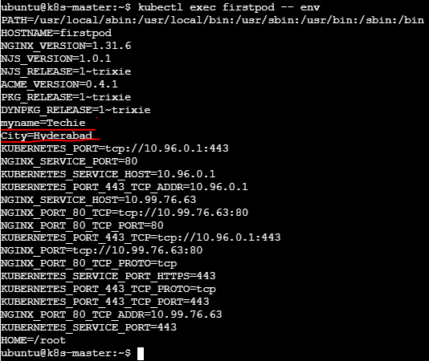

Step 5. Check only these two variables
For a cleaner result:
kubectl exec firstpod -- env | grep -E 'myname|City'

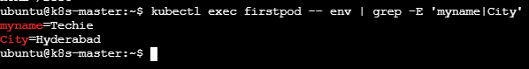
3. Deploy a Pod with Commands (Args) in YAML Task: Modify the YAML file to add args that instruct the container to sleep for 50 seconds. Deploy the Pod and use kubectl describe pod to verify the args are correctly passed to the container.

Step 1. Edit the YAML file

vi firstpod.yaml

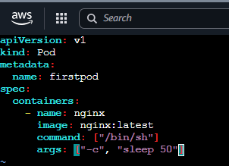

The container will run for approximately 50 seconds, then exit.

Step 2. Delete the old Pod
As we are modifying the Pod configuration, delete the existing Pod first:
kubectl delete pod firstpod

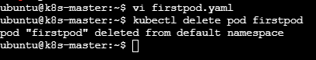

Step 3. Deploy the modified Pod
kubectl apply -f firstpod.yaml
Expected:
pod/firstpod created

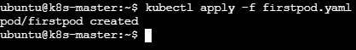

Step 4. Check the Pod
Immediately run:
kubectl get pods

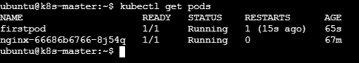

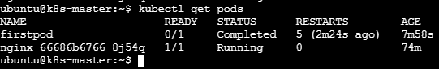

Step 5. Verify the args using kubectl describe
This is the main requirement of your task: kubectl describe pod firstpod
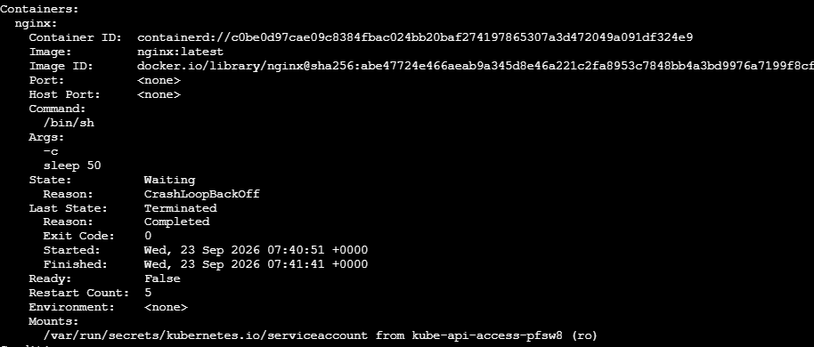
4.Create a Pod with Two Containers Task: Create a YAML file to define a Pod with two nginx containers inside. Use kubectl exec to access both containers and verify that both containers can communicate through the same network (e.g., using telnet between them).

Step 1. Create the YAML file
vi twocontainers.yaml

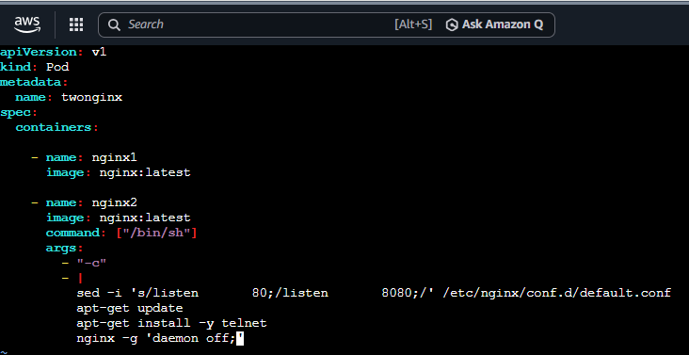
Save and exit.

Step 2. Create the Pod
If you already have a Pod named firstpod, that is a different Pod, so it can remain.
Run:
kubectl apply -f twocontainers.yaml
Expected:
pod/twonginx created

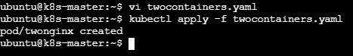

Step 3. Check the Pod
kubectl get pods
You should eventually see:
NAME READY STATUS RESTARTS AGE
twonginx 2/2 Running 0 ...
The important part is:
2/2
This means both containers are running.
If it shows 1/2, wait a little longer because nginx2 has to install telnet.
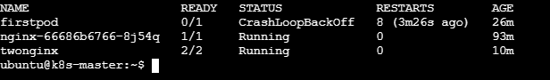

Step 4. Access the first container
Run:
kubectl exec -it twonginx -c nginx1 -- /bin/sh
You should get a shell such as:
#

You are now inside nginx1.
Exit:
exit

Step 5. Access the second container
Run:
kubectl exec -it twonginx -c nginx2 -- /bin/sh
You are now inside nginx2.
Exit:
Exit
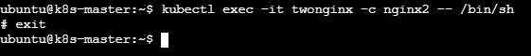

Step 6. Check that both containers have the same Pod IP
Run:
kubectl get pod twonginx -o wide
Example:
NAME READY STATUS IP NODE
twonginx 2/2 Running 10.244.1.5 worker1
Both containers use:
10.244.1.5
because they belong to the same Pod.

Step 7. Test communication between the nodes

Run on the Kubernetes master:
nc -zv <WORKER-IP> 179
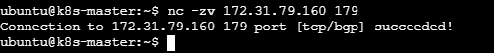

5. Set Up an Init Container in a Pod Task: Modify the YAML to include an init container that sleeps for 30 seconds before the main containers start. Verify the init container's execution using kubectl describe pod and check the logs to confirm its completion.

Step 1. Create the YAML file
Create a file:
vi init-container-pod.yaml

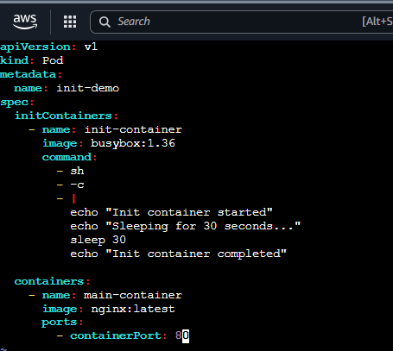

Save and exit.

Step 3. Create the Pod
On Kubernetes master
Run:
kubectl apply -f init-container-pod.yaml
You should see:
pod/init-demo created

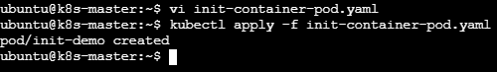

Step 4. Immediately check the Pod
Run: kubectl get pod init-demo
During the 30 seconds, you may see:
NAME READY STATUS RESTARTS AGE
init-demo 0/1 Init:0/1 0 5s
This means:
Init:0/1
The init container is still running.
After approximately 30 seconds, run:
kubectl get pod init-demo
You should see:
NAME READY STATUS RESTARTS AGE
init-demo 1/1 Running 0 40s
Now the init container has completed and the nginx container is running.
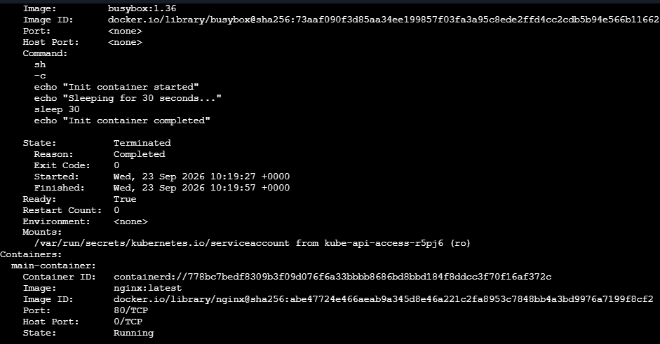

Step 6. Check init container logs
This is another requirement of your assignment.
Run:
kubectl logs init-demo -c init-container
You should get:
Init container started
Sleeping for 30 seconds...
Init container completed
This confirms that the init container executed the commands and completed.
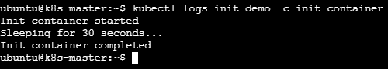

Step 7. Verify the main container
Run:
kubectl logs init-demo -c main-container

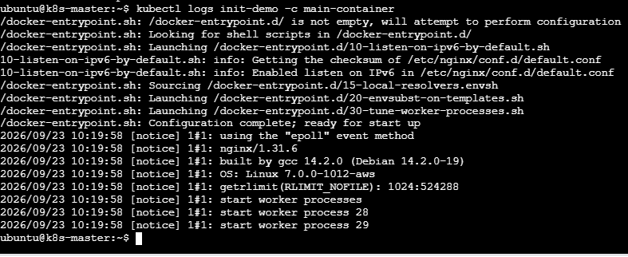
Because nginx normally doesn't write much to stdout during startup, you may not see much output. That's okay.
Instead, verify that it is running:
kubectl get pod init-demo
Expected:
NAME READY STATUS RESTARTS AGE
init-demo 1/1 Running 0 1m
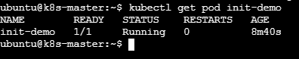
6. Run a Dry Run Command to Generate YAML Task: Use the kubectl run nginx --image=nginx --dry-run=client -o yaml command to generate a Pod YAML definition. Modify the generated YAML to suit specific requirements (e.g., labels or environment variables) and deploy it.

Step 1. Generate the YAML
kubectl run nginx --image=nginx --dry-run=client -o yaml

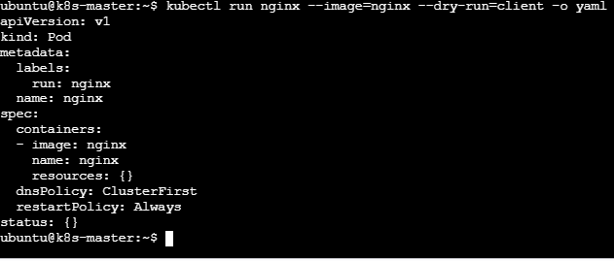

Step 2. Save the generated YAML to a file
Instead of copying the output manually, use:
kubectl run nginx --image=nginx --dry-run=client -o yaml > nginx-pod.yaml
Now check the file:
cat nginx-pod.yaml
You should see the generated YAML.
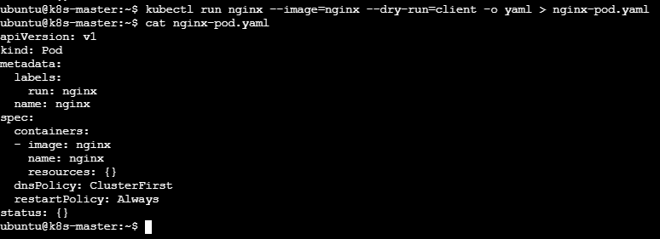

Step 3. Modify the YAML
Open it: vi nginx-pod.yaml
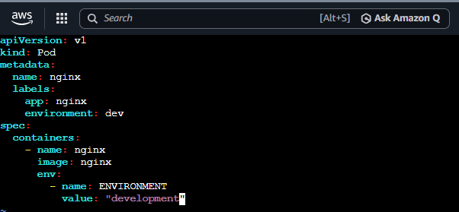

Here we added:

Labels
labels:
app: nginx
environment: dev

Environment variable
env:
- name: ENVIRONMENT
value: "development"
Now save exit

Step 4. Deploy the modified YAML
Run:
kubectl apply -f nginx-pod.yaml
Expected:
pod/nginx created

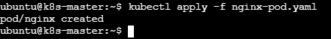

Step 5. Verify the Pod
kubectl get pod nginx
You should eventually see:
NAME READY STATUS RESTARTS AGE
nginx 1/1 Running 0 20s

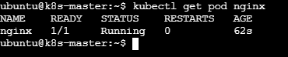

Step 6. Verify the labels
Run:
kubectl get pod nginx --show-labels
You should see something similar to:
NAME READY STATUS RESTARTS AGE LABELS
nginx 1/1 Running 0 30s app=nginx,environment=dev
This confirms your modified labels were applied.
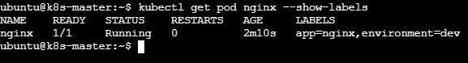

Step 7. Verify the environment variable
Run:
kubectl exec nginx -- printenv ENVIRONMENT
Expected:
development
This confirms the environment variable was successfully added.
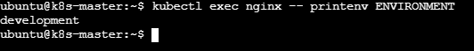

Step 8. View the complete YAML
Check what Kubernetes actually created:
kubectl get pod nginx -o yaml
You should find:
labels:
app: nginx
environment: dev
and:
env:
- name: ENVIRONMENT
value: development
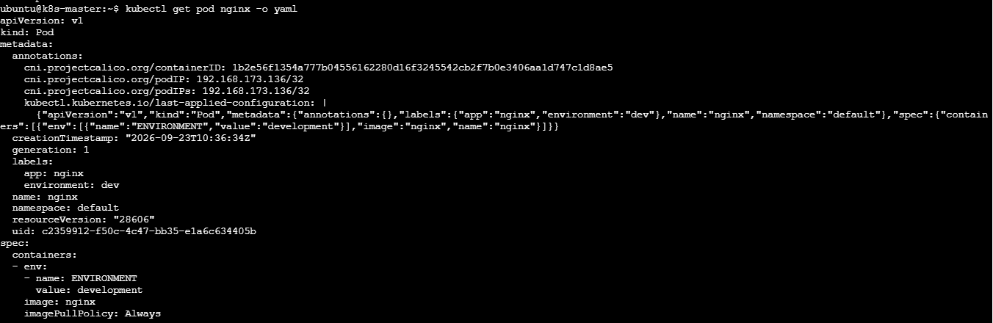
7. Use kubectl apply vs kubectl create Task: Create a YAML file to define a Pod. First, deploy it using kubectl create -f <file_name>.yml and then modify the YAML (e.g., change the image version). Use kubectl apply to redeploy and verify the difference between both commands.

Step 1. Create the YAML file
Create a file:
vi nginx-create-apply.yml

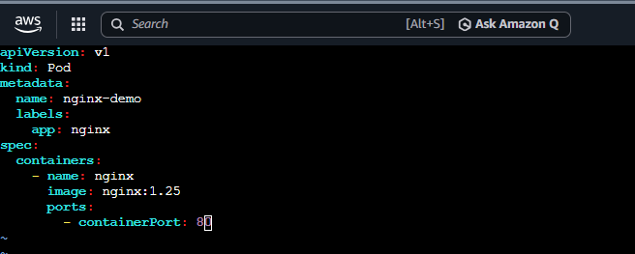
Save and exit.

Step 2. Check the YAML
cat nginx-create-apply.yml
You should see:
image: nginx:1.25

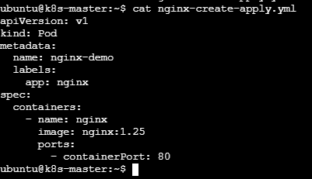

Step 3. Deploy using kubectl create
Run:
kubectl create -f nginx-create-apply.yml
Expected:
pod/nginx-demo created

Check the Pod:
kubectl get pod nginx-demo

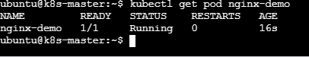

Check the image:
kubectl describe pod nginx-demo | grep -i image
You should see:
Image: nginx:1.25

Step 4. Now modify the YAML
This is the important part.
Open the YAML:
vi nginx-create-apply.yml
Change:
image: nginx:1.25
to:
image: nginx:1.27

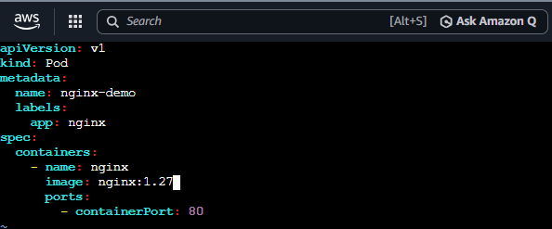
Save and exit.

Step 5. Try kubectl create again
Now run:
kubectl create -f nginx-create-apply.yml
You will get an error similar to:
Error from server (AlreadyExists): pods "nginx-demo" already exists

Why?
Because create means:
Create a new resource.
The Pod already exists, so Kubernetes won't create another Pod with the same name.
Therefore:
create + existing Pod = ERROR

Step 6. Now use kubectl apply
Run:
kubectl apply -f nginx-create-apply.yml
You should see:
pod/nginx-demo configured
This is the important difference.
apply means:
Create the resource if it doesn't exist, or update it according to the YAML if it already exists.

Step 7. Verify the image
Run:
kubectl describe pod nginx-demo | grep -i image
You should now see:
Image: nginx:1.27
You can also run:
kubectl get pod nginx-demo -o jsonpath='{.spec.containers[0].image}'
Expected:
nginx:1.27
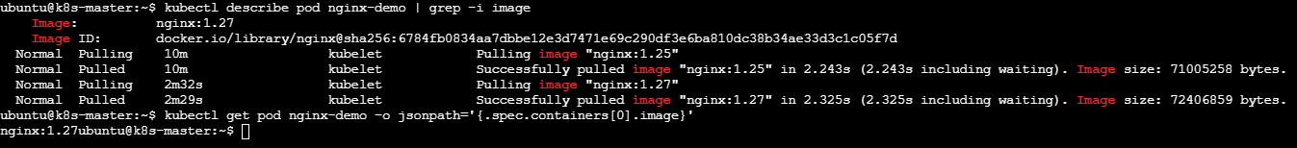
8. Edit an Existing Pod Configuration Task: Use kubectl edit pod <pod_name> to modify the running Pod's environment variables or image. After making the changes, verify if they took effect by checking the container logs or environment variables using kubectl exec.

Step 1. Create a test Pod
kubectl run edit-demo --image=nginx --env="APP_ENV=production"
You should see:
pod/edit-demo created

Check it:
kubectl get pod edit-demo
Expected:
NAME READY STATUS RESTARTS AGE
edit-demo 1/1 Running 0 ...

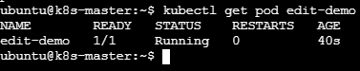

Step 2. Check the current environment variable
Run:
kubectl exec edit-demo -- printenv APP_ENV
Expected: production
So currently:
APP_ENV=production
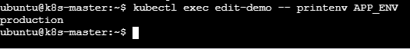
Step 3. Edit the running Pod
Now run:
kubectl edit pod edit-demo
Your editor will open with the Pod's YAML.
Find:
Image : nginx
Change it to:
Image : nginx 1.27
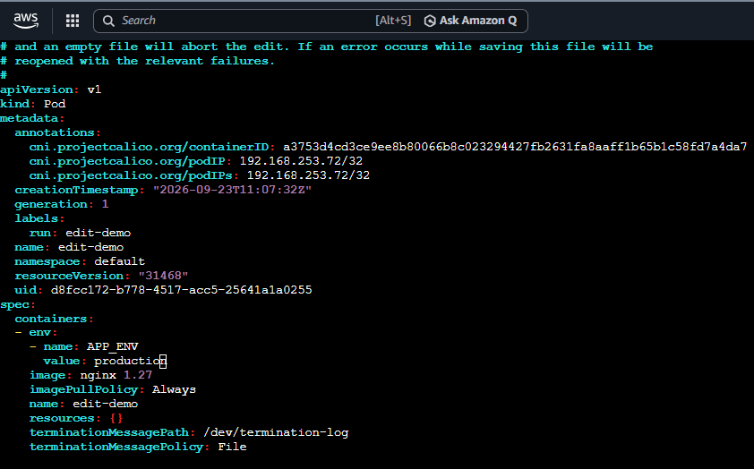
Save and exit.

Step 4. Check whether the change was accepted
After saving, Kubernetes will either accept the change or give you an error.
If you see:
pod/edit-demo edited

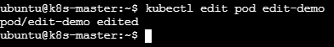
then check:
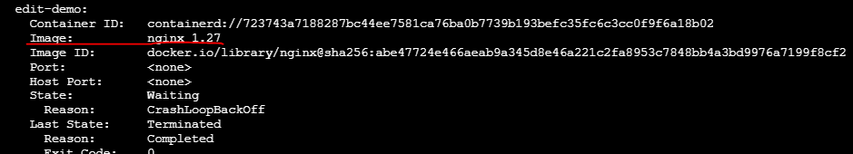
You want:
Nginx 1.27

9. Expose a Pod Using a Service Task: Create a YAML file to expose your firstpod using a Service (ClusterIP). Ensure that your service is exposing the Pod on port 80 and verify it using kubectl get svc.

Step 1. First check that firstpod exists
On your Kubernetes master/control-plane: kubectl get pod firstpod
You should see:
NAME READY STATUS RESTARTS AGE
firstpod 1/1 Running 0 ...
If your Pod has a different name, use that name instead.
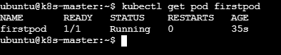

Step 2. Check the Pod's labels
Run:
kubectl get pod firstpod --show-labels
You might see:
NAME READY STATUS RESTARTS AGE LABELS
firstpod 1/1 Running 0 1m run=firstpod
The label is important because the Service uses a selector to find the Pod.
In this example:
selector:
run: firstpod
must match:
run=firstpod

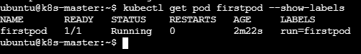

Step 3. Create the Service YAML
On Kubernetes master
Create a file:
vi firstpod-service.yaml
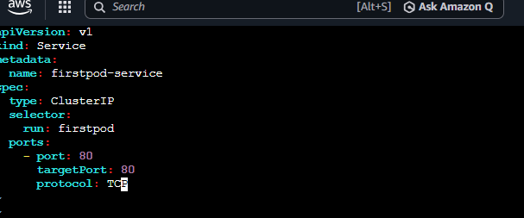
Save and exit.

Step 4. Create the Service
Run:
kubectl apply -f firstpod-service.yaml
Expected:
service/firstpod-service created

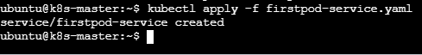

Step 5. Verify the Service

kubectl get svc
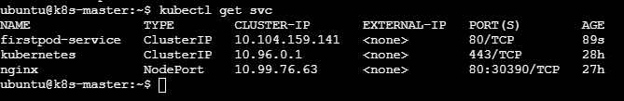

Step 6. Check the Service in more detail
Run:
kubectl describe svc firstpod-service
Look for:
Type: ClusterIP
Port: 80/TCP
TargetPort: 80/TCP
Endpoints: <Pod-IP>:80
For example:
Endpoints: 10.244.1.5:80
The Endpoints line is very important.
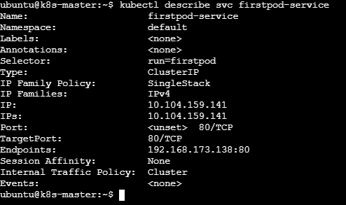
If you see an endpoint, the Service has successfully found your Pod.

Step 7. Verify the Service selector
Run:
kubectl get pod firstpod --show-labels

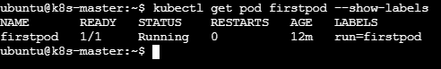
Suppose you get: run=firstpod
Then: kubectl get svc firstpod-service -o yaml
should contain:
selector:
run: firstpod
They must match.
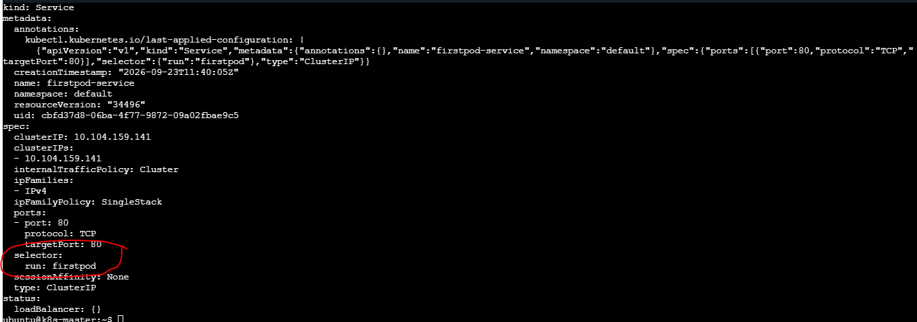

10. Pod with Resource Limits and Requests Task: Add resource requests and limits to the containers in your YAML file. Specify CPU and memory requests/limits for both containers and deploy the Pod. Use kubectl describe pod to verify if the resource configurations are correctly applied.

Step 1 — Create the YAML file
Run on the Kubernetes master:
vi resource-pod.yaml
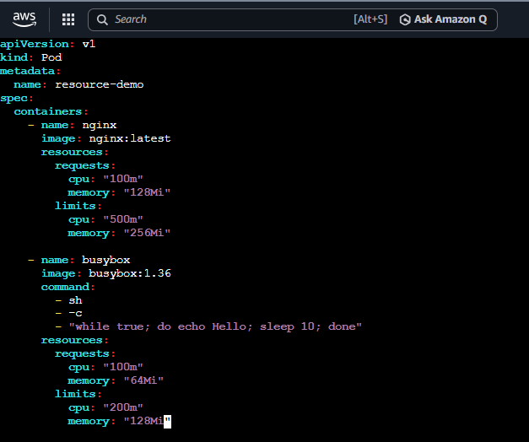

Save and exit.

Step 2 — Deploy the Pod
Still on the Kubernetes master:
kubectl apply -f resource-pod.yaml
Expected:
pod/resource-demo created

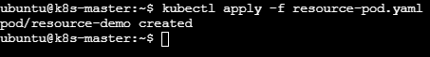

Step 3 — Check the Pod
kubectl get pod resource-demo
Expected:
NAME READY STATUS RESTARTS AGE
resource-demo 2/2 Running 0 ...
2/2 means both containers are running.
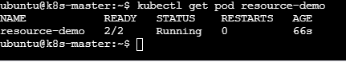

Step 4 — Verify Resource Requests and Limits
Run:
kubectl describe pod resource-demo
Look for the Containers section.
For nginx, you should see something similar to:
Limits:
cpu: 500m
memory: 256Mi
Requests:
cpu: 100m
memory: 128Mi
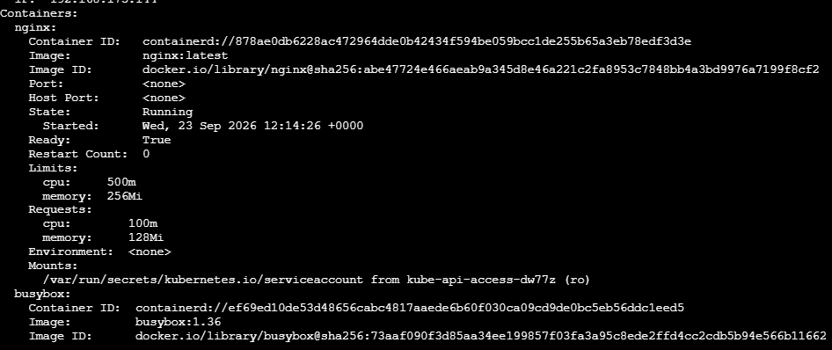
For busybox:
Limits:
cpu: 200m
memory: 128Mi
Requests:
cpu: 100m
memory: 64Mi

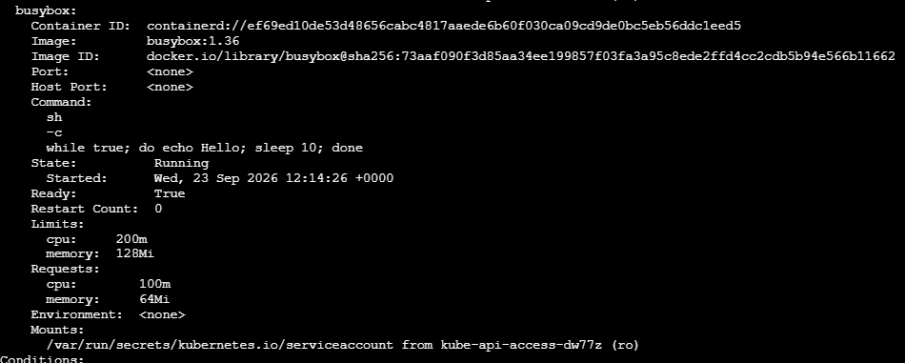

Step 5 — Easier verification
You can also run:
kubectl get pod resource-demo -o yaml
Then search for:
resources:
You will see the configured requests and limits.
